**PROJECT REPORT**

**A COMPREHENSIVE ANALYSIS OF FINANCIAL PERFORAMANCE:INSIGHTS FROM A LEADING BANKS**

**1.INTRODUCTION:**

**1.1 OVERVIEW:**

This session introduces bank financial statements and provides a traditional, ratio-based procedure for analyzing bank financial performance using historical data. It demonstrates the interrelationship between the income statement and balance sheet and describes the risk and return trade-off underlying management decisions.

**1.2 PURPOSE:**

Recognize the basic balance sheet accounts and income statement components and understand how they relate to each other.

**2.PROBLEM DEFINITION & DESIGN THINKING**

**2.1 EMPATHY MAP**

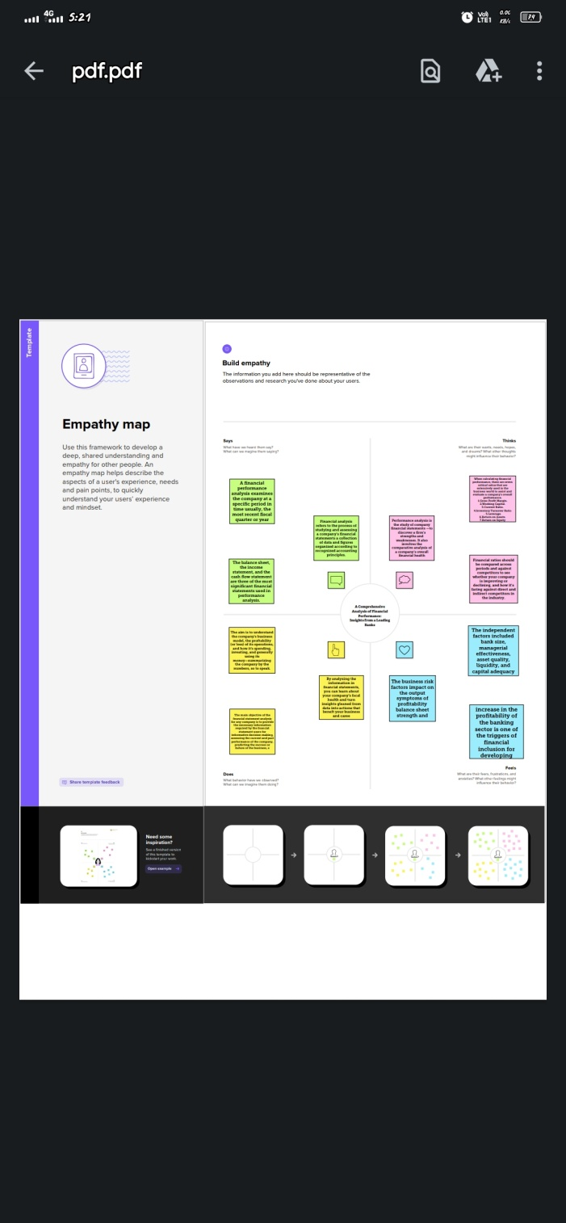

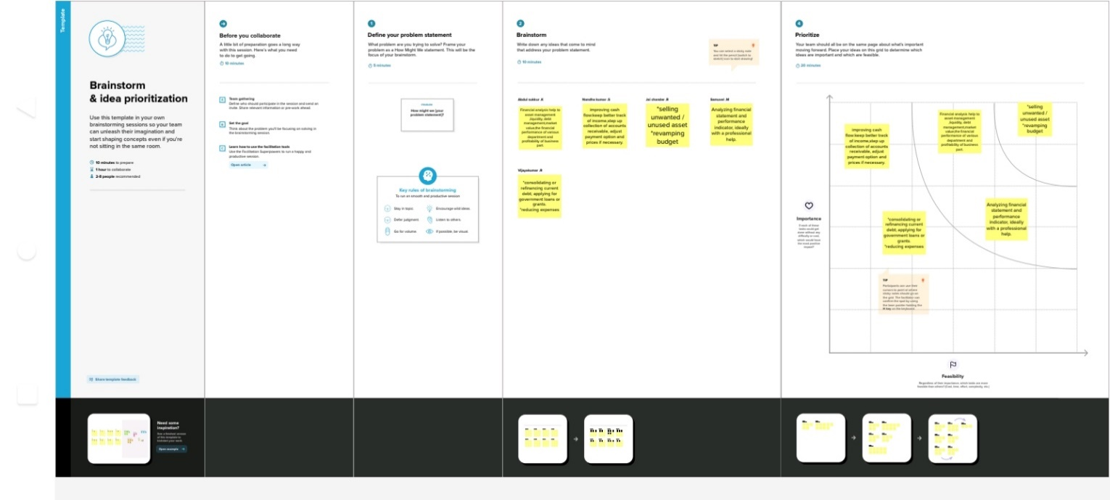 **2.2 IDEATION& BRAINSTOMING**

**3.RESULT:** 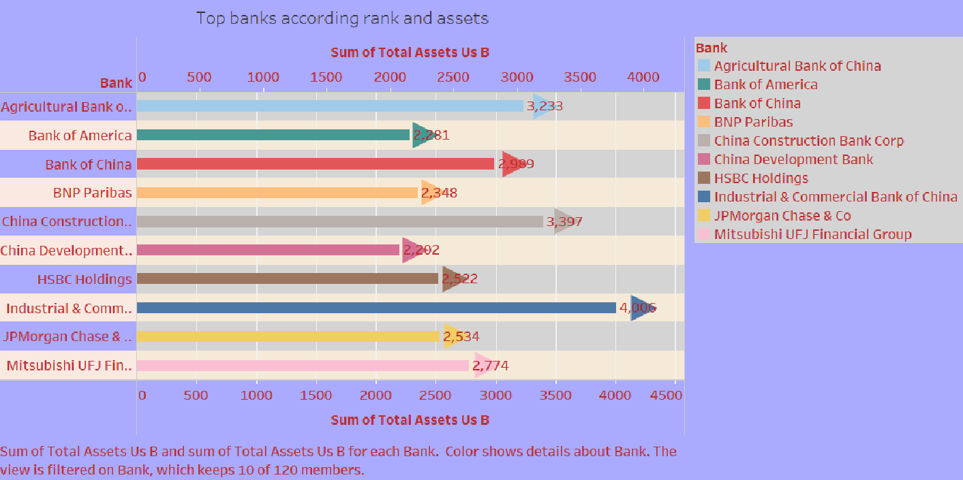

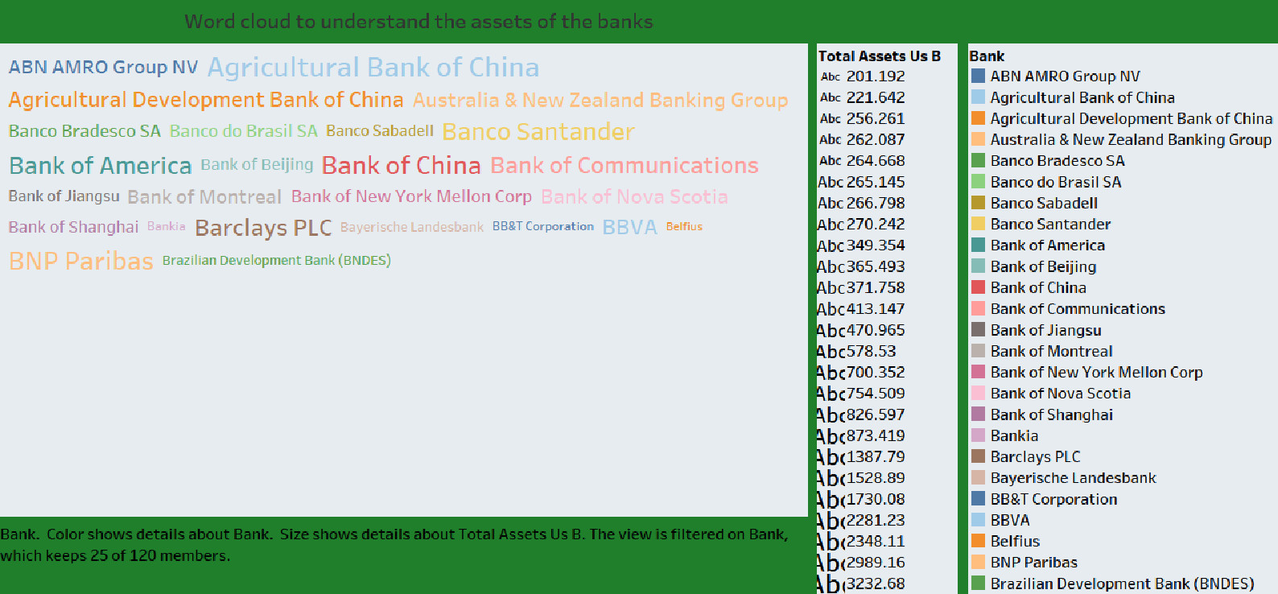

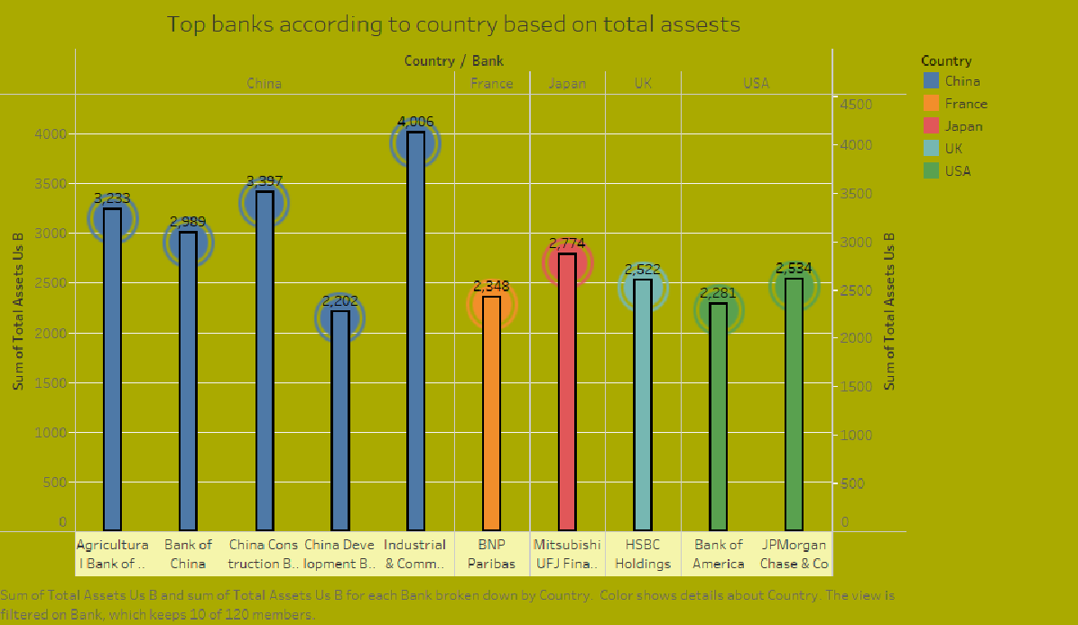

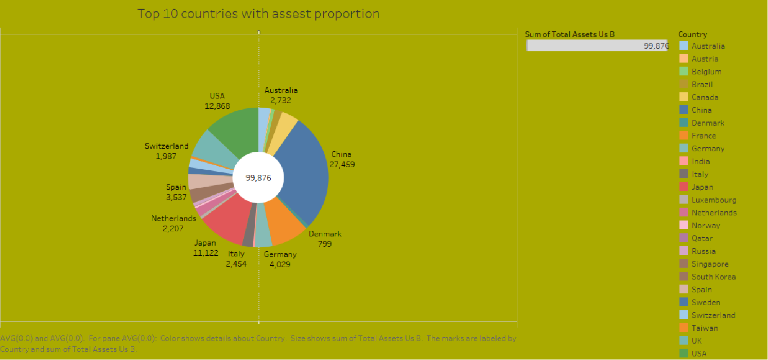

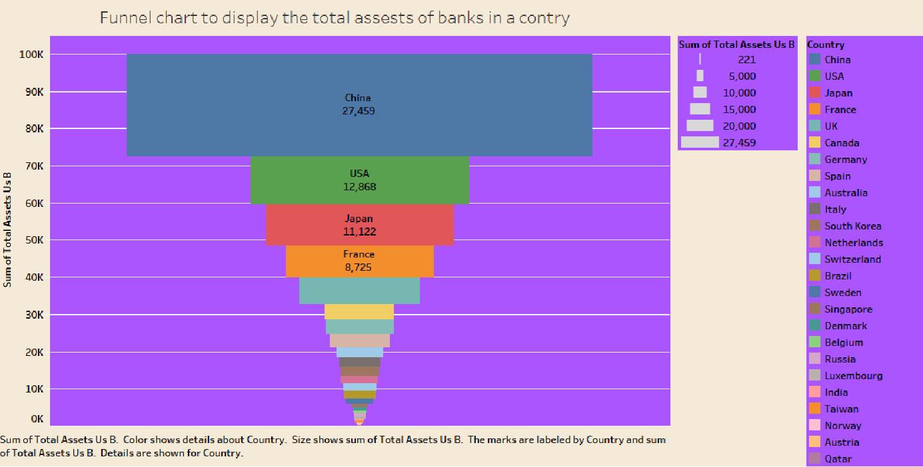

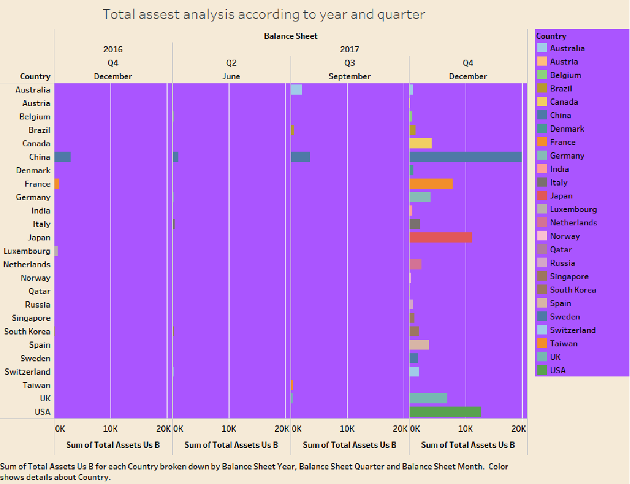

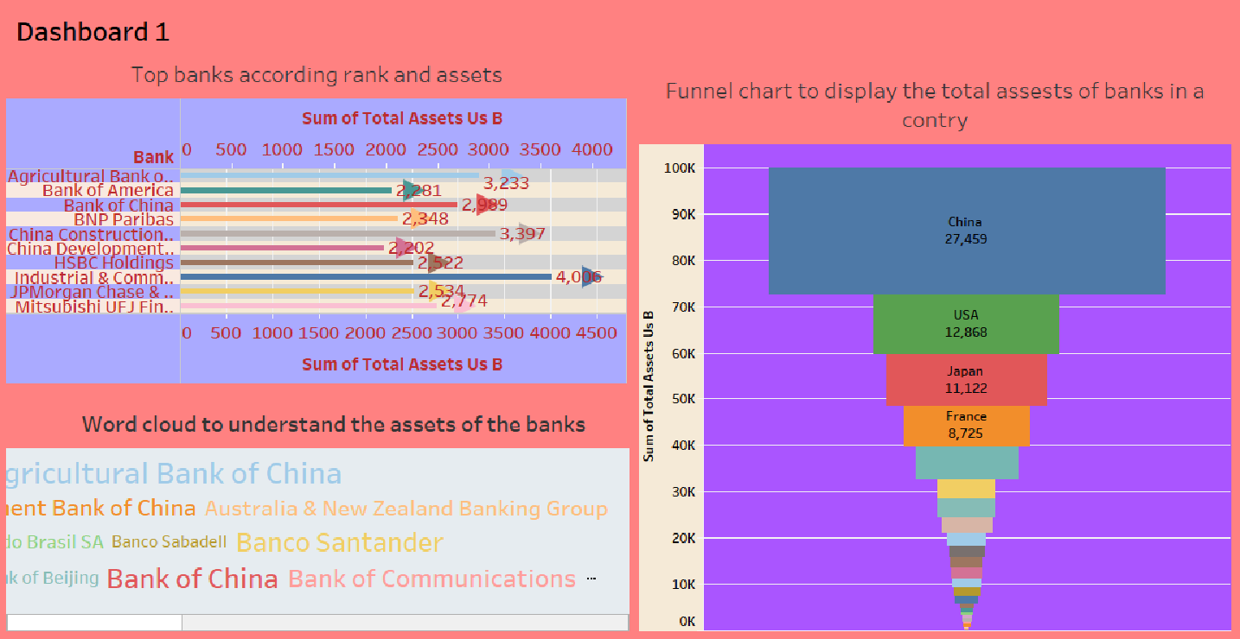

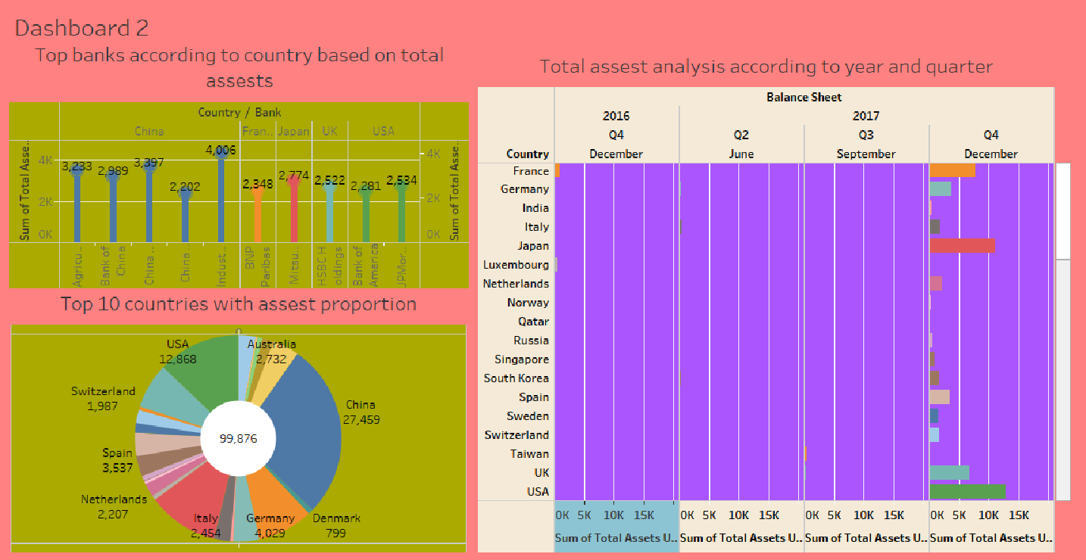

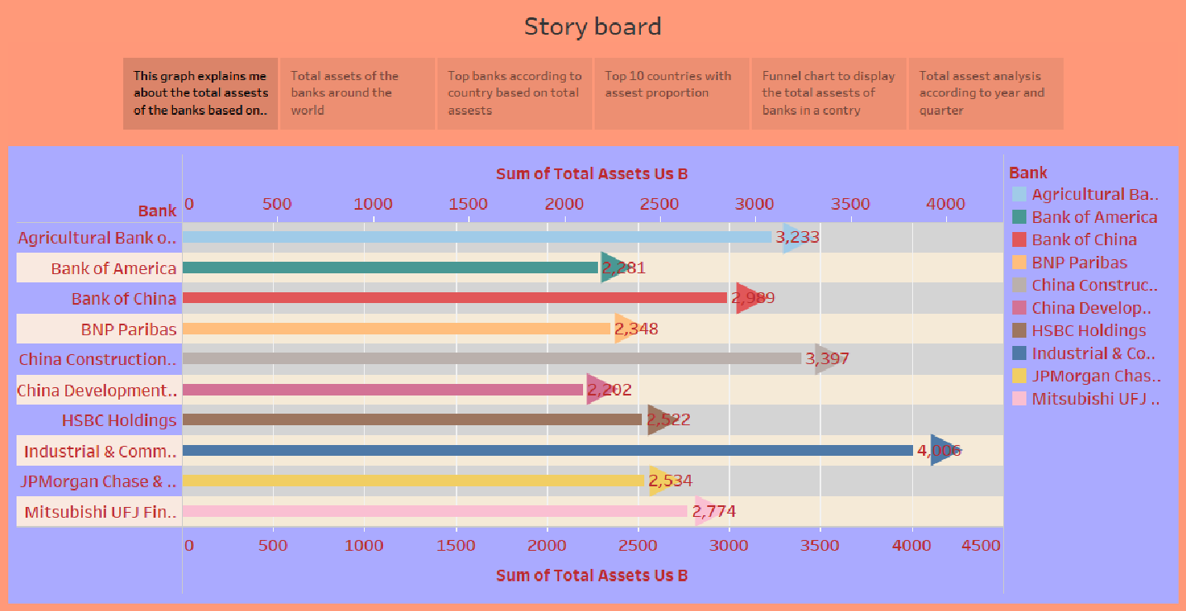

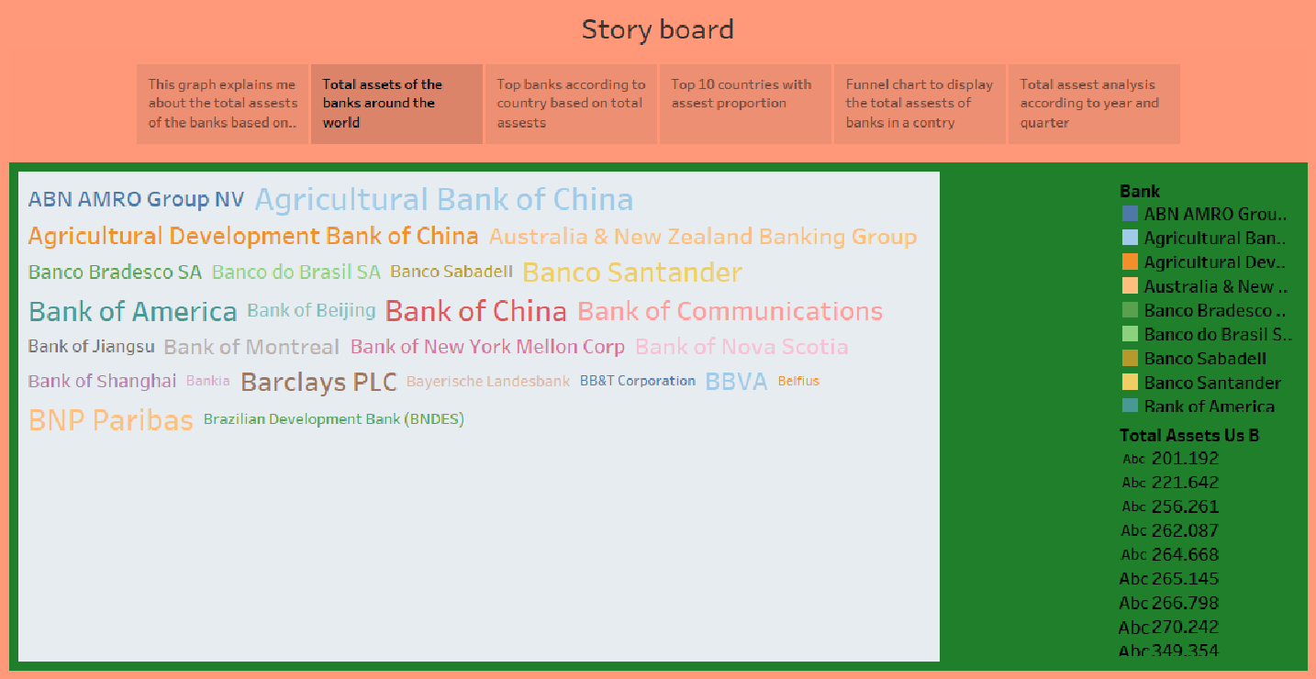

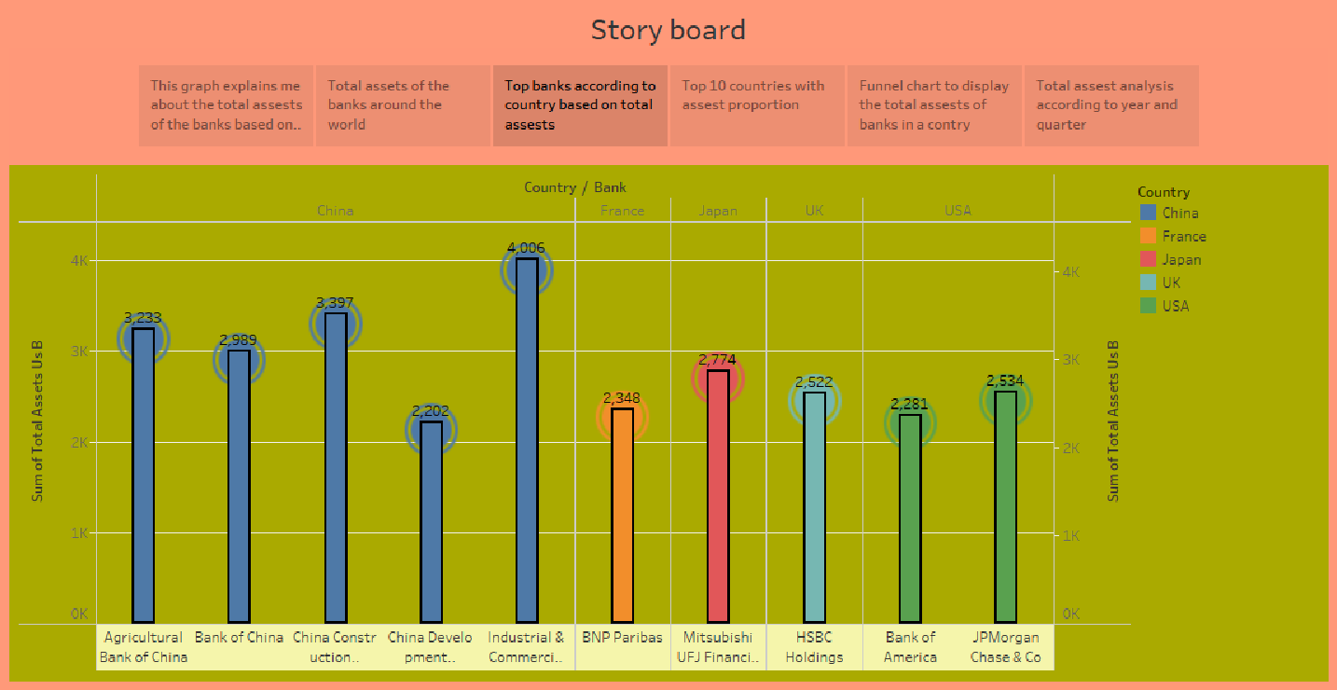

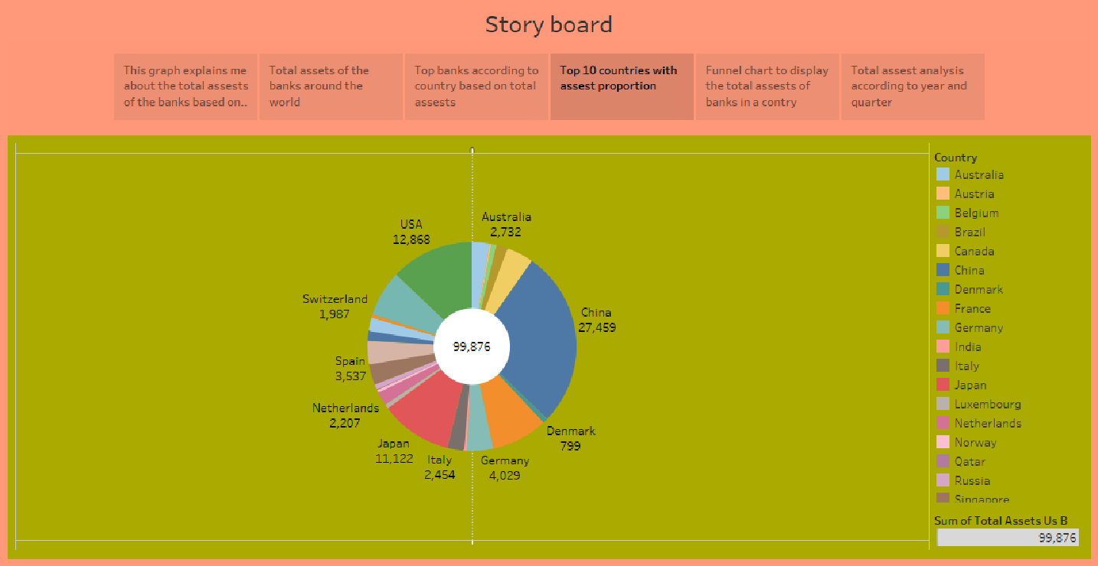

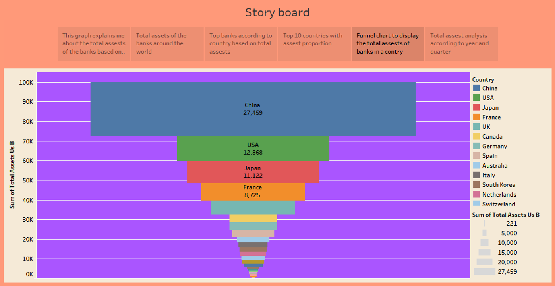

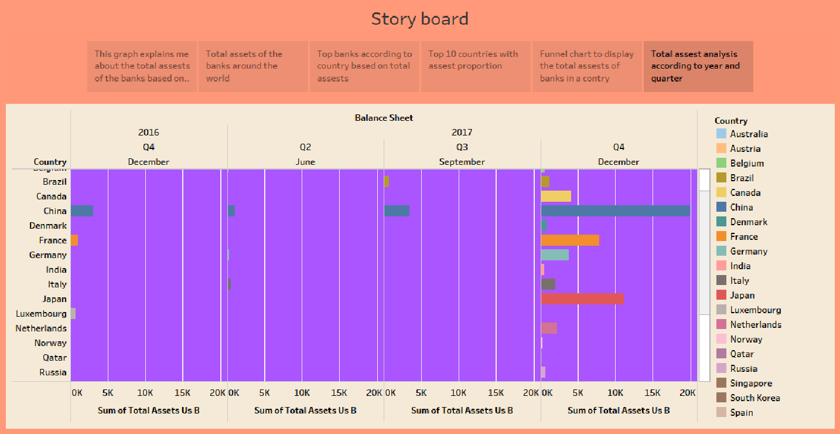

**4.ADVANTAGES & DISADVANTAGES**

**Advantage: The Ability to Detect Patterns**

Financial statements reveal how much a company earns per year in sales.

The sales may fluctuate, but financial planners should be able to identify a pattern over years of sales figures

## Advantage: A Chance to Budget Outline

Another advantage of using financial statements for future planning and decision making is that they show the company’s budgets.

## Disadvantage: Based on Market Patterns

One disadvantage of using financial statements for decision making is that the data and figures are based on the market at that given time

## Disadvantage: At-One-Time Analysis

Another disadvantage is that a single financial statement only shows how a company is doing at one single time.

**5.APPLICATION:**

The primary purpose of doing a financial analysis of a project is to evaluate the project's profitability or cost-effectiveness relative to some alternative project or investment.

Frequently, the results of the financial analysis are used to compare alternative projects to select which ones should be implemented.

**6.CONCLUSION**

1. Bank assets can generally be classified in one of four categories: cash and equivalents, investment securities, loans, and other assets. a bank's net income can be divided into four components that potentially reveal differences in performance: net interest income, provision for loan losses, burden, and taxes.
2. The ROE model provides a means of analyzing the source and magnitude of banking profits over time and against peer banks. It describes the relationship between return on equity and a bank's return on assets and equity multiplier. It then decomposes return on assets into its contributing factors
3. There are seven fundamental risks in banking: credit risk, liquidity risk, interest-rate risk, capital (solvency) risk, operational/fraud risk, off-balance sheet risk, and foreign exchange risk.
4. There is a fundamental trade-off between bank profitability and risk. A bank that reports above average profits either takes on above average risk or realizes a competitive advantage in offering some product or service.
5. Different-sized banks exhibit different profitability and risk profiles because they serve different types of customers and operate in different geographic markets. Wholesale banks work primarily with commercial loan and deposit customers. Retail banks focus primarily on consumer customers 7. The Uniform Bank Performance Report (UBPR) is available quarterly for anyone to evaluate a bank's risk and return performance.

**7.FUTURE SCOPE:**

The study is based on the financial position of the firm by using Ratio analysis, Trend analysis and Comparative statements. Financial statements help the management to analyze profit, solvency, liquidity and efficiency etc. this analysis will give the exact picture of the company.